COWBOY CRUNCH

Design Document

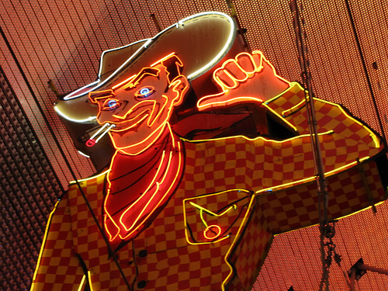

By Joel Draper

Contents

**Revisions** 3

**Type Conventions** 3

**Synopsis** 3

**Introduction** 3

**Assets** 3

**Audio** 3

**Character** 3

**Enemy** 3

**Environment** 3

**Promotional** 4

**Characters** 4

**Data Storage** 5

**Gameplay** 5

**Graphics** 5

**Target Platform** 5

**User Interface** 5

**Development** 5

# **Revisions**

|  |  |  |  |
| --- | --- | --- | --- |
| **Version** | **Author** | **Date** | **Comments** |
| 0.1 | Joel Draper | 23rd April 2015 | Initial Plan and Pitch |

# **Type Conventions**

All regular text is in Size 11 Calibri.

Table headers are in **Size 11 bold Calibri.**

Header titles are in **Size 14 bold, underlined copper plate Gothic Bold.**

Sub header titles are in **size 12 bold, underlined copper plate gothic bold.**

# **Synopsis**

You are a lone cowboy whose livelihood is under threat. Bandit gangs want to end your life, and as you cross the dessert more and more bandits appear trying to take you out. On top of that, you have to dodge cactuses, dynamite and other western paraphernalia. You must shoot bandits and avoid all the various traps.

# **Introduction**

Cowboy Crunch is an indie 2D run ‘n’ gun shooter/platformer in which the player must kill as many bandits as they can and avoid various Wild West themed traps such as TNT and cactuses in order to survive. Replay ability comes from the fact that the game gets harder and harder as you go along and has no end, so you’re trying to beat your previous high score.

The game is designed to be an action packed and fun to play while also being pick up and play so that the player doesn’t have to follow a story – making it great for playing on the bus. Also as it keeps on getting harder and harder and has no end, there is no need for later support with added levels to keep up the games shelf life.

# **Assets**

Assets required for the game are detailed below, as the game is designed to be developed over 3 months, the asset development schedule is included.

## **Audio**

* A “Wild West” arcade sounding piece of music that can loop without becoming too repetitive
* A comic style “pow” pistol sound effect
* Angry Mexican bandit yelling
* A comic style explosion sound effect for TNT

## **Character**

* A small, basic pixel cowboy complete with Cowboy hat, Brown clothing and trusty revolver.

## **Enemy**

* Small, basic pixel style bandit complete with bandana and trusty pistol.

## **Environment**

* Basic pixel cactus.
* Sand ground sprite
* Dessert background
* Sticks of dynamite
* Old fashioned style mine complete with pickaxes, dirt background and wooden support beams
* Dirt ground sprite for mine ceiling and floor

## **Promotional**

* Logo for the main menu

# **Characters**

The main character of the game is player character, an **unnamed cowboy** who’s travelling through the dessert defeating the endless bandit army that keeps attacking him. Roughly middle aged, he was previously in a gang and the bandits want revenge for what he did while in this gang. He has no defining features as he is a small, pixel character minus his trusty cowboy hat, boots and revolver. He is a small, basic cowboy that is designed to be about 8-16 pixels tall to pay homage to old games from the 1980’s.

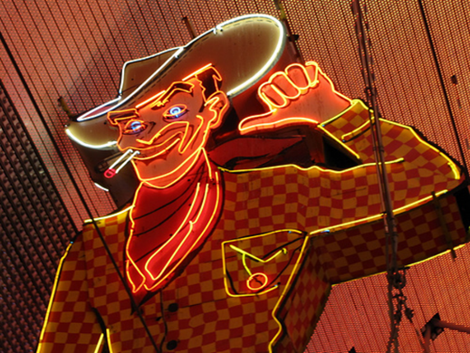

Figure 1 - Vegas Vic, one of the inspirations for the main character

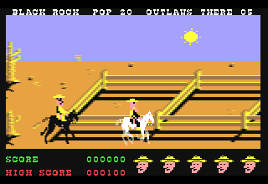

Figure 2 - A character from the 1987 game Outlaw. Similar to how I want the main character to look.

The **bandits** have a stereotypical look about them, being similar in size and detail to the player, but having trademarks of the stereotypical western bandit rather than the stereotypical western cowboy, with the bandits having a bandana covering their face, for example – while still being of a similar size and having a revolver.

# **Data Storage**

# **Gameplay**

# **Graphics**

# **Target Platform**

# **User Interface**

# **Development**